A) Why Website development required ?
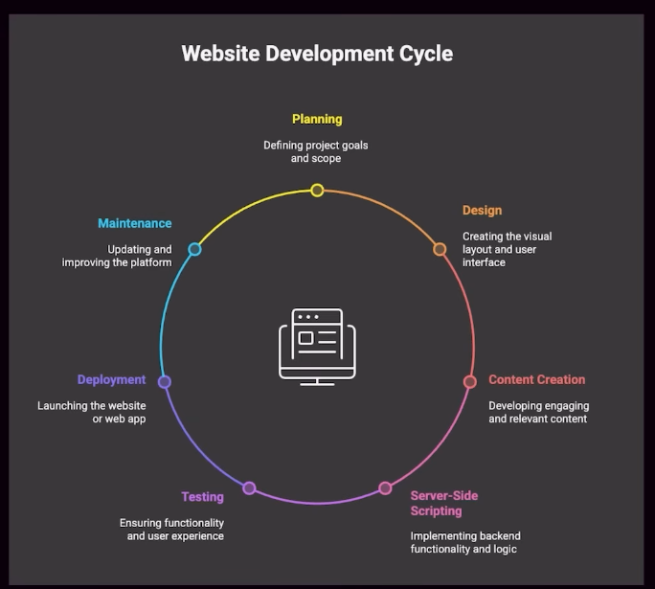
Ans :- Website development is required to create and maintain websites that provide information, services, or solutions to users through the internet.

B) What Is frontend ?
Ans :- Those thing you see in our eye and interact. This is frontend.
C) What Is Backend ?
Ans :- Those thing you not see in your eye and interact . This is backend.
D) What Is Database ?
Ans :- Those place all the type of data are store, this place is called database.

Example of Frontend , backend, database :-
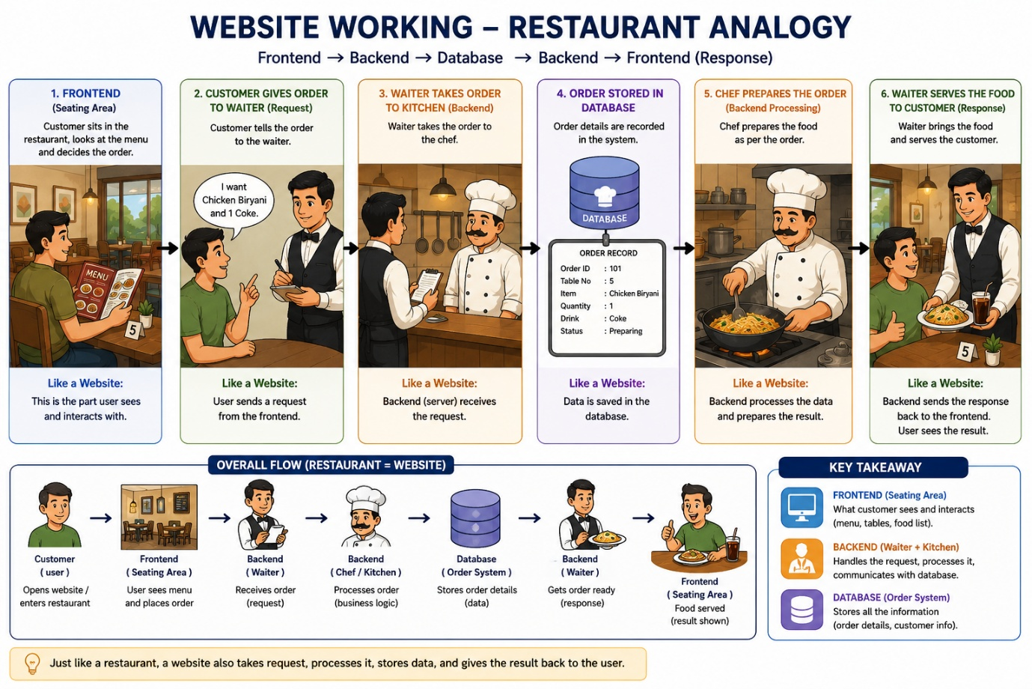

E) Frontend Development Technology :- HTML, CSS, JS
F ) Backend Development Technology :- Python, Java script, Java, PHP
G) Database :- MySQL, MongoDB, PostgreSQL, SQLite
H)

